**7**

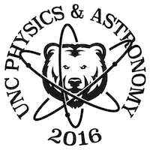

University of Northern Colorado

Department of Physics and Astronomy

Ross Hall 0232

Campus Box 127

Greely, CO 80639

If found contact Josh Fender

720-345-1650